THE STEVENSON PLACE

SHANGRI-LA

APRIL 2025 ISSUE 322

EDITOR: Sue PAGE 1
Whats Happening this Month  Apr 01: April Fool’s Day  Apr 02: Happy Birthday Pat  Apr 05: Happy Birthday Sally  Apr 08: Window Cleaning 8:00AM  (Please close all your windows)  Apr 09: Live Music @ 1 PM  Apr 11: Happy Birthday Helen  Apr 15: Residents Coffee Meeting  @ 10:30 AM  Apr 18: Good Friday  Apr 19: BINGO @ 1:30 PM  Apr 20: Easter  Apr 27: Wine with Dinner  Apr 29: Happy Birthday Grace C.   | TIPS/REMINDERS FOR RECYCLE BINS  - Clothing, if not donated locally, goes in the garbage, not the recycling.  - Old flowers and dead plants go in the garbage, not recycling. In households, their true home should be a compost bin.  - Returnable juice, pop and liquor bottles/boxes go in the separate marked garbage cans.  - Soiled paper towel/toothbrushes/plastic wrap and plastic bags all go in the garbage.  - List of what is not recyclable on the wall to the left of the bins.  Mini Moves Notice Mini Moves chair exercises with Magi will be changing from Mondays and Fridays to Mondays and Wednesdays starting April 2nd.  Welcome  A warm welcome to new resident Judy Hughes. Wishing you happiness and many friendships in your new home.
THE STEVENSON PLACE
SHANGRI-LA

APRIL 2025 PAGE 2
BEE PREPARED  (For those that were bugged by these pests last year)    Say what you want about wasps, but at least they wear high visibility jackets to prevent accidents. | The Faces of Stevenson  The wall of pictures is now complete (with the exception of Judy) and available for your viewing in the hallway near the dining room. Great job by Irene, Aline, Lucy and Gary and much appreciated by all the residents.  “You look marvelous, darlings”  TODAY’S CHUCKLE  Two wrongs are just the beginning  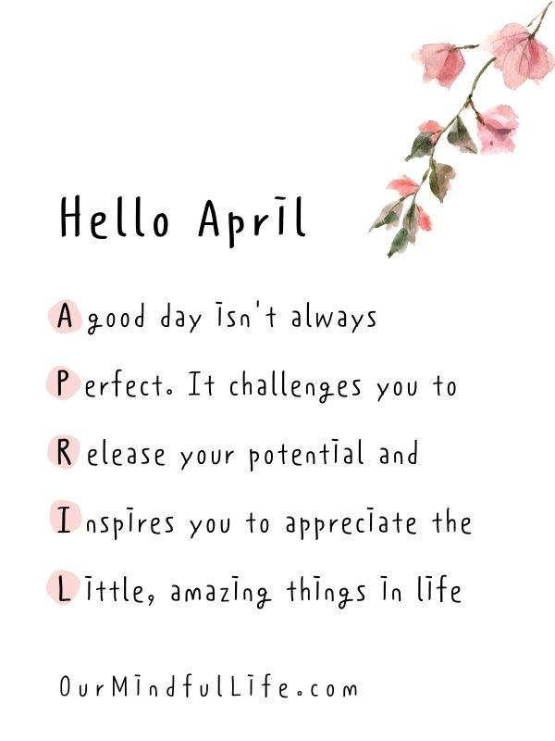

THE STEVENSON PLACE
SHANGRI-LA

APRIL 2025 PAGE 3
Interesting Occurrence  On October 10, 2024, a BBC Weather app and website data malfunction caused incorrect forecasts, displaying impossibly high wind speeds and temperatures, leading to widespread confusion and social media reactions.  A fault with a third-party weather data supplier led to the BBC Weather app and website displaying incorrect data, including wind speeds of 13,508 mph in London and temperatures of 404°C in Nottingham.  The BBC Weather app and website showed hurricane-force winds and extreme temperatures, far exceeding any real-world weather conditions.  The BBC Weather acknowledged the issue and data weather presenters reassured users on social media and TV bulletins that the forecasts were incorrect. BBC weather fixed the issued and it was removed from the website. | Riddle of the month  How do you spell “cow” in 13  Letters? (See Sue for the answer)  BINGO RESULTS  12 players for March Bingo. Five of the games had single winners; Summer, Hilary, Helen, Terry and Tineke. Game five’s win was shared between Fran, Helen and Penny. Thanks Joe, for calling and to Clara for organizing and set up.  A woman is walking home with her 3 daughters. The eldest daughter turns to her and asks, "Mummy, how did I get my name?" "Well sweetie, when we were bringing you home from the hospital, a rose petal landed on your head! So that's why we named you Rose.” The second daughter, now curious, asks the same question. "Well darling, when we were bringing you home from the hospital, a lily petal landed on your head! So that's why we named you Lily." The third girl asks "HHGHGNGHGHNG?!?!?! DDDNBHGHBHNGHHH!!!"  "Shhh, quiet now, Cinderblock."
THE STEVENSON PLACE
SHANGRI-LA

APRIL 2025 PAGE 4


“April hath put a spirit of youth in everything.”

The English word April comes from the Latin Aprilis, the name given to the month by the ancient Romans. No one knows for certain why the Roman’s named it as they did. Some Roman authors thought that Aprilis was related to the Latin verb aperire meaning “to open,” because April “opened” the buds of leaves and flowers.

April is the first full month of spring, the weather is warmer and there are even a couple of holidays to celebrate such as April Fools’ Day, Earth Day and Easter. It’s a time of revival after a cold winter season, so it’s no surprise that this month is full of energy in the air – out with the old and in with the new!

Those born in April are known for their optimism. Some research demonstrates that April babies live healthier lives and excel at their careers. People born in March, April and May score high on what’s called the hyperthymia scale. Hyperthymia is the scientific term for general optimism, so April babies are also likely to see the glass as half-full or find the silver lining in every situation.

Welcome
A warm welcome to new resident Judy Hughes. Judy has been u

