STEVENSON PLACE

SHANGRI-LA

AUGUST 2025 ISSUE 326

EDITOR: Terrina PAGE 1
Charles ‘Candy’ Rogers  The son of a Massachusetts farmer, Charles Rogers wandered west and arrived in Victoria in 1885, at the age of 31. He opened a ‘green grocery’ on Government Street and alongside his fruits and vegetables, he sold chocolates he imported from San Francisco. Tourists and locals alike flocked to his store for the chocolates, and recognizing an opportunity, he decided to make them himself. Using trial and error, Charles combined his fruits with the finest, freshest ingredients available, and Rogers’ Chocolates were born. Charles married Leah Morrison in 1888, and they had one son, Frederick, in 1890. With the untimely death of their only son, the grief-stricken couple buried themselves in their work. Charles would post a sign outside the shop with the store’s operational hours, and when the door opened, customers would be lined up down the street. His wares would be sold out within the first hour, and the store would be shuttered until the next day. In the afternoon, the couple prepared their chocolates for shipping, as Rogers’ Chocolates were being enjoyed all over the world. The Rogers lived a simple life and kept to themselves. Charles bought his wife furs and diamonds, and nothing pleased him more than to have her sit with him in the kitchen thus adorned while he worked. | What’s Happening this Month:  August 2 – 4: Nautical Days!  August 4: Celebrate B.C. Day!  Blueberry Muffins 11 am  August 6: Brain Gym 11 am  August 9: Bingo! 1:30 pm  August 14: Stevenson Place Celebrates  28 Years! Happy Anniversary  Country Club Theme Party  August 23: Bingo! 1:30 pm  August 31: Wine with Dinner  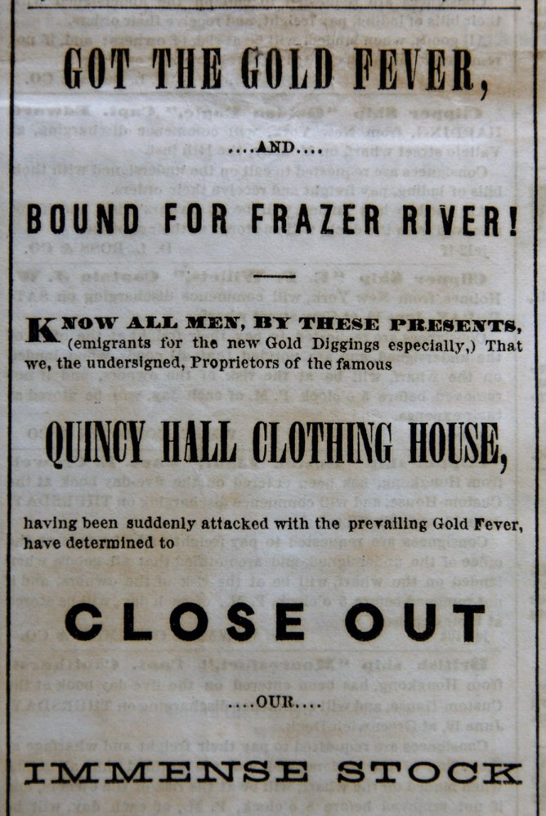  Summer declines and roses have grown rare,  But cottage crofts are gay with hollyhocks,  And in old garden walks you breathe an air  Fragrant of pinks and August-smelling stocks.  —John Todhunter (1839-1916)
STEVENSON PLACE
SHANGRI-LA

AUGUST 2025 PAGE 2
Harry Houdini Performs Escape in Vancouver  On March 1, 1923, Harry Houdini was in Vancouver, at the Orpheum Theatre, performing as part of a vaudeville show. The famed ‘master of escape’ accepted a challenge to be suspended high up in the air outside the Sun Building at 125 West Pender Steet while shackled in chains and bound in a straitjacket. About 10,000 people showed up to watch the world-famous escape artist, anxious to see if he would be able to wriggle his way out of his self-imposed predicament. Two Vancouver police detectives were chosen to bind Houdini, who was then hoisted, hanging upside down by his ankles, high above the street. It took him only three minutes and thirty-nine seconds to extricate himself from his constraints.  The amazing feat was filmed and shown that night at the Orpheum Theatre, with Houdini in the audience.  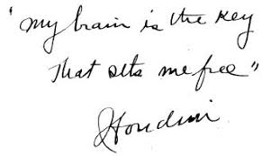  “My Brain is the key that sets me free”  Houdini | A Peek Back at July  Our month began with our traditional Canada Day Lunch, and the weather was beautiful, so lunch was served on the patio. Nine residents attended, and the event added $18.10 to the coffers of the residents’ fund. At dinner, we raised a glass and toasted our magnificent country, as Canada celebrated its 158th birthday. Nine residents enjoyed live music by Steve & Vivian Ruskin on July 16th. They had our toes tapping, and our heads bobbin’ as they entertained us with some old favourites. July 3rd, the much-anticipated rematch of our summer Bocce game ended in a dead heat. July 17th found the teams reassembled with each one hungry to claim a victory. It was a real nailbiter, with the crowd cheering everyone on, the gentlemen squeaked out a win by one point! The ladies will be looking to even the score next time. Bobby celebrated 25 years of working at Stevenson Place on July 24th, and we appreciate his dedication and loyalty.  Movies on Sunday will be played at your request. Feel free to pick one from our collection of DVD’s in the library. Our upcoming anniversary party is a country club theme this year, with live music at 1 pm by Tereza and company, set up in the parking lot so that you can dance!

STEVENSON PLACE
SHANGRI-LA

AUGUST 2025 PAGE 3
August Folklore  Peel back the curtain and peek into the past before telephones, cell phones, television and the internet; a time when communities relied upon the sharing of folklore and legends to understand their world. The primary purpose of folklore was to pass down the wisdom, knowledge, and cultural values from one generation to the next. In today’s fast-paced world, it is a reminder of the importance of storytelling; it has the power to bring people together, whether around a campfire, a festival or in a family setting. Folklore teaches moral lessons, preserves historical events, and provides entertainment. Folktales often embody the collective wisdom of a community, offering insights into social norms, fears, and aspirations of the people who share them.  August 1, traditionally known as Lammas Day, was an old festival to mark the annual wheat and corn harvest. It was similar to Thanksgiving, (as in harvest time) in Britain. Lammas also marked the mid-point between the summer solstice and autumn equinox.  “After Lammas Day, corn ripens as much by night as by day.” | Cat Nights begin on August 17th, correlating back to a rather obscure Irish legend concerning witches, when cats were thought to be their ‘familiars’. It was believed that a witch could change from her human form into a cat, but only eight times, as on the ninth time she would lose her human form forever. This bit of folklore also contributed to the belief that a cat has nine lives.  - As August, so February.  - Observe on what day in August the first heavy fog occurs and expect a hard frost on the same day in October.  - If the first week of August is unusually warm, the winter will be white and long.  - So many August fogs, so many winter mists.  - When it rains  in August,  It raises honey  and wine.  August is a fabulous stargazing month! The Perseid meteor shower is one of the most prolific showers, watch for it between August 11 – 13, when it is at its maximum.
STEVENSON PLACE
SHANGRI-LA

AUGUST 2025 PAGE 4
1858
New Caledonia. This name referred to the mainland of British Columbia before it became a formal colony of Britain. Prior to 1858, from the perspective of Britain, with its massive empire, New Caledonia was of little interest, being too far away and of insignificant value to the mother country. Until the rumors of gold being discovered in the Fraser River spread south to the United States and reached such a fever pitch that even the Hudson Bay Company, with all their power couldn’t keep it quiet. Nuggets weighing 800 ounces were sent to San Francisco in February 1858 for assessment, and information concerning the treasure trove soon leaked to the media. In March newspapers in Washington and Oregon reported the discovery of gold in the sandbars of the Fraser River, shortly thereafter the California papers heralded the find. To miners accustomed to the glory days of the California Gold Rush, which had since dissipated and left many unemployed, the news of this discovery instigated a mass migration by land and sea. The first wave of about 400 California miners arrived in April 1858. By May and June, this number swelled as thousands of men flocked to the wilds of New Caledonia, flooding the banks of the Fraser River from Hope to Lillooet hoping to make their fortunes or die trying. The massive influx of American gold seekers triggered fears that this would lead the United States to try and annex the non-sovereign British territory. James Douglas, a high-ranking officer employed by the Hudson’s Bay Company was the Governor of the Colony of Vancouver Island, based in Fort Victoria. He didn’t want the delicate balance of the empires’ position in the fur trade to be threatened by the invasion of these largely American treasure hunters. Without political authority, and acting on his own initiative, Douglas tried to keep the gold rush from spinning out of control. He worked to exert British jurisdiction over the mainland by stationing a warship at the mouth of the Fraser in order to issue licenses to the prospectors and merchants hoping to cash in on the booming business of the gold rush. It was on his advice that an imperial act of parliament established the territory of New Caledonia into the crown colony of British Columbia on August 2, 1858, thereby squashing any nefarious plans of the United States to gobble up our land. If it weren’t for James Douglas, would Canada’s beautiful borders stretch from the Atlantic to the Pacific? Thank goodness we never had to find out.

