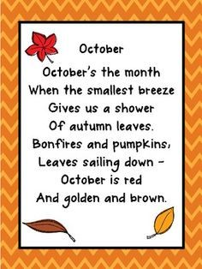OCTOBER ECHO 2025

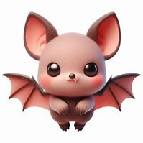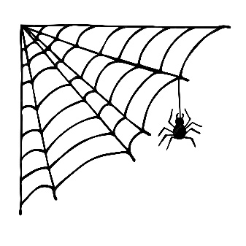

October Birthday Wishes

Alice Pearson Oct 3rd

Bertha Smith Oct 11th

**Welcome to Wedgwood House**

**When you see our new residents say Hi**

**Garth & Doris Foster moving into 301**

**Rosemarie Painchaud moving into 310**

**Bob Pearce moving into 312**

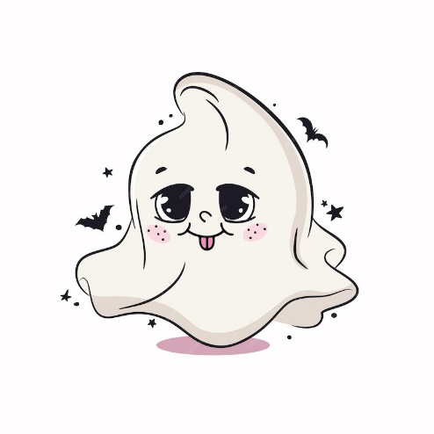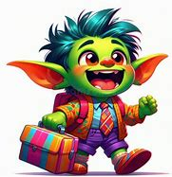



Fall is here

Come join us

Sunday’s at 12:30 p.m.

Pick your movie

On Netflix

Pull up a chair

And grab some pop corn

**HALLOWEEN DAY**

**AND SPOOKY**

**NIGHTS**

**OCT 31TH**

**COME JOIN IN THE FUN**

**BRIAN & CATE**

**4:00 TILL 5:00**

**FOLLOWED**

**AT 5:30 P.M.**

**A**

**SPOOKTACKULAR DINNER**

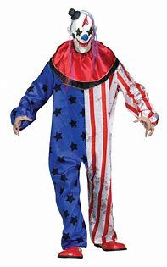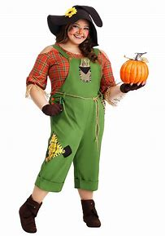

**DRESS UP IN YOUR**

**HALLOWEEN COSTUM**

**1T, 2ND, 3RD**

**PRIZES**

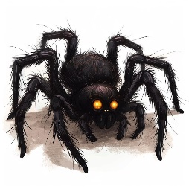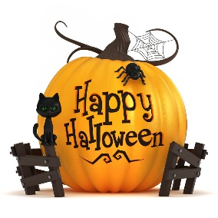**October Jokes that will make you smile**

**Why did the scarecrow win an award in October?**

**Because he was outstanding in his field!**

**What’s a ghost’s favorite month?**

**Spooktober!**

**Why did the skeleton go to the Halloween party alone?**

**Because he had no body to go with him!**

**What do whiches use to do their hair in October?**

**Scare-spray!**

**Why did the vampire get a job in October?**

**He wanted to work the graveyard shift!**

**Why did the mummy go to school in October?**

**To improve his wrap sheet!**

**What’s a pumpkin’s favorite sport?**

**Squash!**

**What do you call a ghost that haunts a bakery in October?**

**A sweet spook!**

**Why do ghosts love riding in elevators in October?**

**It lifts their spirits!**

**How do you fix a broken Jack-O-Lantern?**

**With a pumpkin patch!**

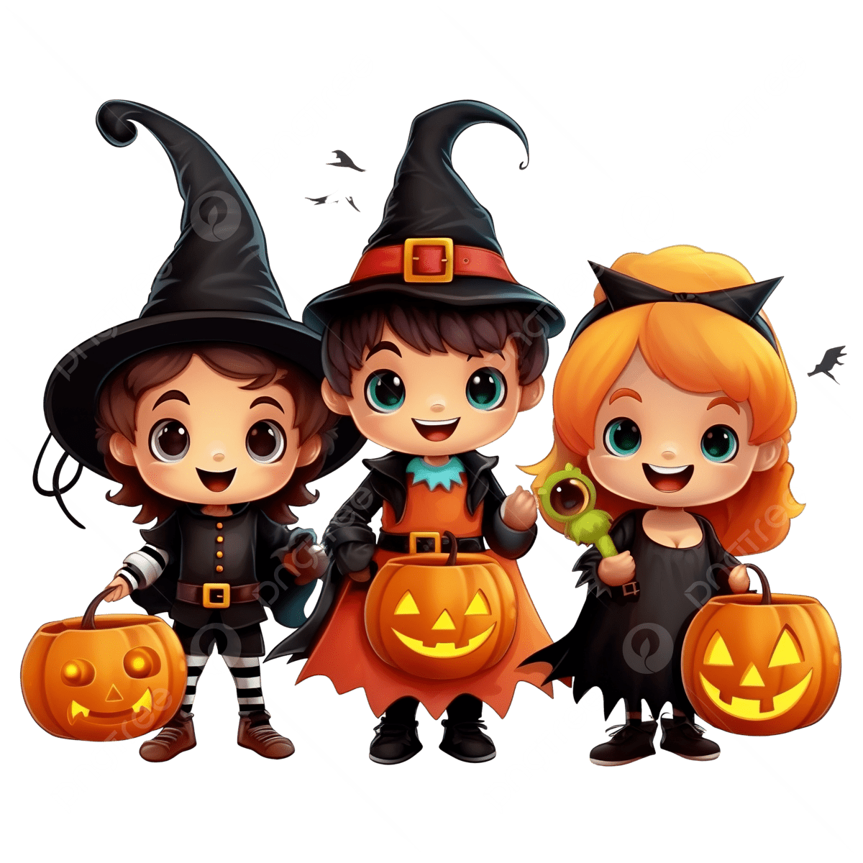**What do you call a haunted chicken in October?**

**A poultry-geist!**

**How do you make a witch scratch?**

**Take away the “w”!**

