

ECHO 2025

All good things must come to an end. Summer has faded away. Get ready for cooler weather and shorter days which means longer nights.

The first of the month brings us a rush of children running to school every which way. An influx of traffic on all the roads so just beware.

**FALL IS FALLING**

Garden and fields have been harvested. The bounty full of fruit and vegetables have been processed, canned or frozen. All the trees are now turning the fall vibrant color of red, orange and yellow.

Soon fall will be over

With a blink of the eye

Then it will be winter. BRRRRR

**Birthday Wishes**



**Sue Parmenter Sept 13th**

**Birthdays are nature’s way to telling us to eat more cake**

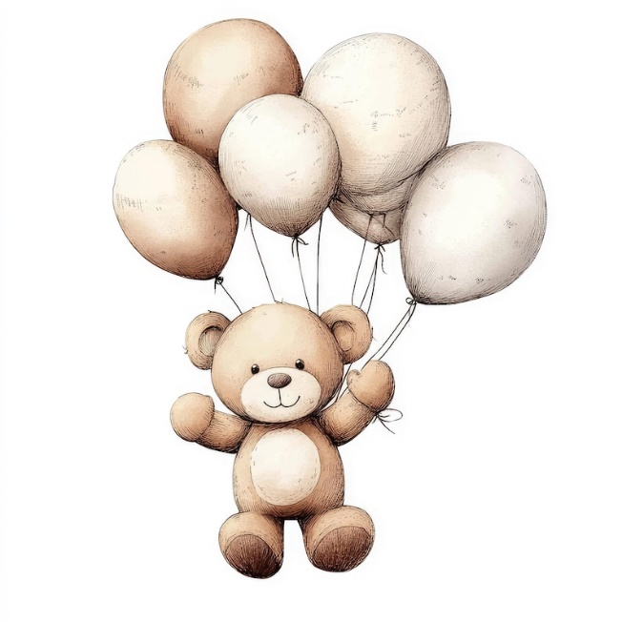**Have a fun and relaxing day**

BC coast is known for earthquake and tsunami actives.

Earthquake and Tsunami Preparedness Guide



**Dust mask to help filter**

**contaminated air**

**First-aid kit**

**&**

**Medications**





**Copy of your**

**Emergency plan,**

**Copies of important**

**Documents such as**

**Insurance papers, and**

**Identification, and**

**Cash in small bills**

**Garbage bags and**

**Moist towelettes for**

**Personal sanitation**



**Water, four litres per**

**Person per day, for**

**At least two weeks,**

**For drinking and**

**sanitation**



**Non-perishable**

**Food: for at least two**

**Weeks, with a manual**

**can opener**



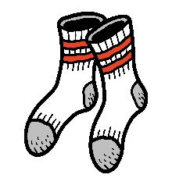

**Seasonal clothing,**

**Sturdy food wear and**

**Emergency blanket**

**Battery-powered or**

**Hand-crank flashlight**

**And extra batteries**



**Battery-powered**

**Or hand-crank**

**radio**

**Phone charger,**

**Power bank or**

**inverter**

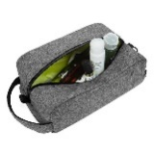

**Personal toiletries**

**And items such as an**

**Extra pair of glasses or**

**Contact lenses**

**Whistle to signal**

**for help**

Be Prepared Grab and Go

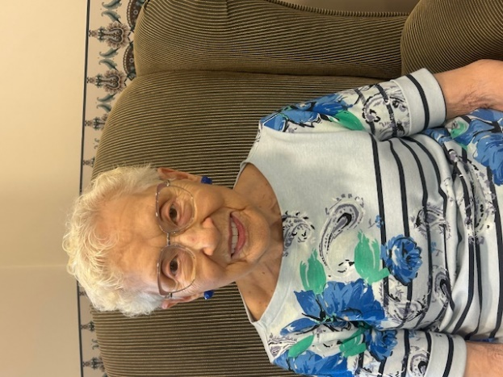

Betty Louise Panzer (Oakes)

January 29, 1929

I was born in Limerick, Saskatchewan, fifth child of six, born to Gladys and Samuel Oakes. Raised on a farm at Wood Mountain, Saskatchewan our home was filled with lots of love and the sound of music. Variety of instruments were heard throughout the house. From Grandma Hicks old pump organ, banjo ukulele, guitar, to harps. Plenty of opportunity to learn a different instrument for all the sing along.

The first nine years I went to Guidford. Many fond memories walking three miles to and from school with my classmates. We had to be very cautious going through the neighbors’ pasture for they had a bull that was not very nice.

Our first electrical lights that we had in our house was run by a windmill on the property. If there was no wind there was no power which meant reverted back to the old kerosene and gas lanterns.

17 Miles east of where we lived there was a town called Lisieux. A cheese factory and the local general store was owned by Mr. Chretien. My father delivered milk to the cheese factory, making various stops along at different farm for their milk. Empting all the cans into a large vat for the day’s cheese making. The cans would be refilled with whey from the previous day’s makings. The full cans would be delivered back to the farms to feed their pigs.

The local grocery store would not have to pay for the incoming milk supply a credit was given to the various families for their grocery and staple supplies.

In the late 1940 the family suffered a great loss of my eldest brother Garrould. Left a terrible hole in all of our lives. He was an excellent musician. Not only losing Garrould most of our young men were enlisted to go to war. This was a very trying time. Hard on the farming community for putting myself and my sibling more work to do on the farm

I met my husband Ole Panzer. Married later on in Feb 26 1947. After Ole was discharged from the army we moved to Fife Lake, Sask. being a grain buyer Olli received free room and board along with a small wage. It was a struggle farming at that time. Severe weather put a strain on all the crops for three years forcing Ole to work in a local grocery store.

In 1951 we packed up our car and drove to Vancouver Island and settled in Duncan. We bought our first home that summer using our car and $400.00 for a down payment. I taking a part time job at our local hospital. Ole worked various jobs from carpentry, logging and a floor finisher.

Our family started to grow. We had two sons Garth and Blare. We enjoyed them to the fullest for they kept us very busy with all the different sports. Ole in his younger years played baseball, hockey. I joined Ole in some competitive curling and later on I joined bowling and would bowl twice a week

In the 80’s Ole and I built on our property and English style Neighborhood Pub called the Oak and Carriage. The business was a great success but had taken a toll on Ole health. In 1985 Ole lost his battle with lung cancer needless to say I was devastated. Faith and time are great healers. I then took an early retirement and traveled.

I do not have problems convincing myself to see my son and family who live in Kahului, Maui when needing a holiday. I have now settled nicely in to Wedgwood House. Which I call home now.

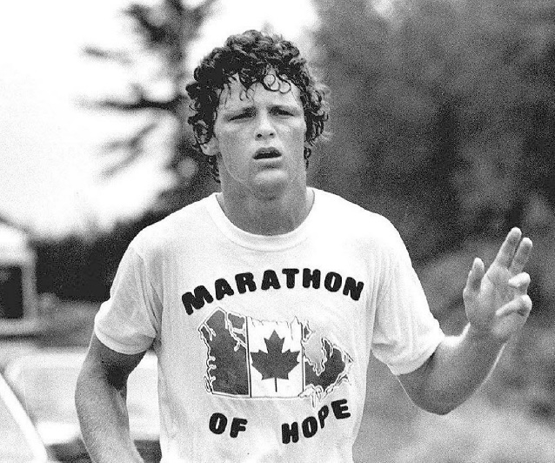

July 28, 1958 - June 28, 1981

Forty four years ago Terry Fox lost the battle to cancer. Terry Fox became an inspirational figure and national hero through his Marathon of Hope. A race across Canada, he raised millions of dollars for cancer research. Terry was diagnosed with cancer in 1977. Cancer progressed to the amputation of one of his legs above the knee.

Terry was a very focused man. He was determined to beat this disease. Terry was going to make a difference not only was it unheard of walking long distance on an artificial leg, but to run? It was going to be a challenge. Learning to run, he completed a marathon. This inspired him to run across Canada. Which he then called the Marathon of Hope.

Initially Terry did not receive much attention or money, but that changed when he continued to run. Covering up to 30 miles per day. Fortunately half way into his journey cancer had spread.

Terry made such an impacted prior to his death, the government had made him the youngest ever Companion of the Order of Canada he was twice named Canadian of the Year for the Terry Fox Runs, which are organized by the Terry Fox Foundation held annually in cities throughout Canada and other countries.

Please on Sept 14th Wedgwood is hosting a box luncheon

Support with your donation

What is the answer to these puzzle?



