|  |  |
| --- | --- |
| **THE STEVENSON PLACE** SHANGRI-LA | |
| OCTOBER 2025 ISSUE 317  EDITOR: Sue PAGE 1 | |
| **September Review**  The Patio Social and Bocce game on September 4th was a real close competition. Men versus women with one of the ladies knocking the winning ball closest, resulting in an end of summer win, which was enjoyed along with lemonade and chips.  The music of Donna & Evan was enjoyed by many on September 9th. Although no dancing on the tables occurred, many did tap their toes and sing along to some old favorites.  The September 20th Bingo saw Sally & Louise with 2 wins. Fran, Judy & Laurine each got a win. I guess the bingo angel wasn’t sitting on Jim’s shoulder this month.  We saw the change from a beautiful sunny August to the beginning of Fall on September 22nd. The leaves started changing color early this year due to the lack of summer precipitation. The Old Farmer’s Almanac indicates that we, in Southern BC, will have above average rainfall this winter. Dig out your wellies! | ***Whats Happening this Month***  Oct 02: Happy Birthday Penny  Oct 04: Brain Gym at 11:00 AM  Oct 07: Ears to You Clinic 10-3pm  Oct 13: **Thanksgiving** Traditional  Turkey Dinner  Oct 14: Happy Birthday Marcel Oct 15: Live Music at 1:00 PM  Oct 18: BINGO at 1:30 PM  Oct 25: Brain Gym at 11AM  Oct 26: Wine with Dinner  Oct 31: Halloween – prizes at  dinner for best costume    45 MAXINE HALLOWEEN ideas | maxine, bones funny, halloween |
| **THE STEVENSON PLACE**  **SHANGRI-LA** | |
| OCTOBER 2025 PAGE 2 | |
| **ARE THESE WORDS FOR REAL?**  **Taradiddle**: Means bogus, nonsense or a lie.  **Macaronic**: Looking to find this word on an Italian dinner menu topped with cheese? You won’t. It refers to when someone mixes two different languages together.  **Fubsy**: Nope, it’s not a creepy Furby knockoff. Fubsy means squat or portly.  **Absquatulate**: It doesn’t mean doing squats to improve your abs! It means to flee or abruptly leave or decamp.  **Cabotage**: Does not mean sabotage a taxi driver! It means the transport of goods & passengers between two places in the same country.  **Firkin**: It is not a dirty word, nor is it a catlike creature that can swallow things 10 times its size. It refers to a small tub or vessel.  **Oxter**: As much as I would love to tell you that it is a group of oxen & otters that became friends, that would be a lie. It is an outdated term for armpit.  **Agelast**: This does not refer to the fountain of youth! It means someone who never laughs, and you definitely don’t want to be that person.  **Lickspittle**: Um, ew? It means brown-noser or kiss-up. | **New to Us**  A belated, but nevertheless, warm welcome to Hanna Stuart, who joined our Stevenson family throughout July/August.  An early hello and welcome to newcomer Edith Strocen who will be moving in on October 6th.  **Small Cat Kitten Cute Cat Drawing" Art ...CATS**  They are incredible creatures with unique traits. Each cat’s nose is unique, similar to a human fingerprint. Cat’s have a third eyelid called a “haw” that helps protect and moisten their eye. Their whiskers are roughly the same width as it’s body to help it determine if it can fit through a space. Cats have over 20 ear muscles and 180-degree rotation of their ears for excellent hearing. They can see in low light conditions 6 times better than humans. Cats meow to communicate with humans, not each other. They walk like camels & giraffes, moving both right feet then both left. Cheers to Blue, Mopey & Gilbert, Stevenson's feline residents. |
| THE STEVENSON PLACE **SHANGRI-LA** | |
| OCTOBER 2025 PAGE 3 | |
| **A LITTLE SEASONAL HUMOUR**  Two Nuns and a Mini Dracula  Two nuns, Sister Mary Agnes and Sister Mary Vincent, are traveling through Europe in their car, sightseeing in Transylvania. As they are stopped at a traffic light, out of nowhere, a small vampire jumps onto the hood of the car and hisses at them through the windshield.  "Quick, quick!" shouts Sister Mary Agnes, "What should we do?"  "Turn the windshield wipers on. That will get rid of the abomination," says Sister Mary Vincent.  Sister Mary Agnes switches on the wipers, which knock the mini-Dracula around. But he hangs on and continues hissing at the nuns. "What shall I do now?" she shouts.  "Try the windshield washer. I filled it with holy water before we left the Vatican," replies Sister Mary Vincent.  Sister Mary Agnes turns on the windshield washer. The vampire screams as the water burns his skin, | but he hangs on and continues hissing at the nuns.  "Now what?" shouts Sister Mary Agnes.  "Show him your cross," says Sister Mary Vincent.  "Now you're talking," says Sister Mary Agnes. She then opens the window and shouts, "Get the hell off our car!"  Vampires  "If I were a bird, I would fly about the Earth seeking the successive autumns." – George Eliot |
| **THE STEVENSON PLACE**  **SHANGRI-LA** | |
| OCTOBER 2025 PAGE 4 | |
|  | |
|  | |
|  | |
|  | |

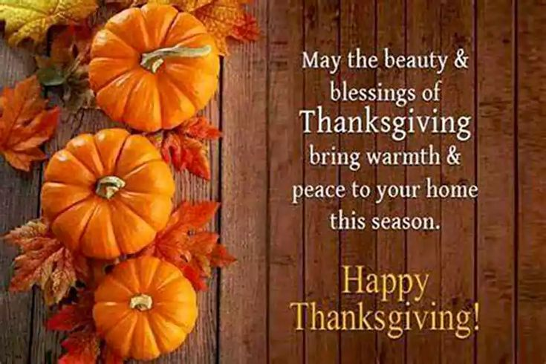

**Halloween Groaner**

A man was walking home alone one night when he heard a "BUMP....BUMP.... BUMP..." behind him. Walking faster, he looked back, making out an image of an upright coffin banging its way down the middle of the street towards him...."BUMP...BUMP...BUMP..."

The man began to run toward his home, and the coffin bounced after him faster.... faster...BUMPBUMPBUMP.

He ran up to his door, fumbled with his keys, opened the door, rushed in, and locked it behind him. The coffin crashed through his door, with the lid of the coffin clapping BUMP...BUMP...BUMP... on the heals of the terrified man. The man rushed upstairs to the bathroom and locked himself in, heart pounding.

With a CRASH, the coffin broke down the door, coming slowly toward him.  The man while screaming, reached for something, anything...all he can find was a box of cough drops which he hurled at the coffin...and suddenly "the coffin stops."

